ECE2170: Brief tour of Nonlinear Systems

# Goals of this lab

* Perform analysis on simple non-linear systems
* Measure frequency responses for simple non-linear systems
* Demonstrate use-cases for non-linear systems

# Background

## Nonlinear systems

As opposed to Linear Time Invariant (LTI) systems, nonlinear systems do **not** obey the principles of linearity and superposition. Consequently, these systems do not generally have sinusoids as eigenfunctions; a single sinusoid input does not provide a single sinusoid out. In this lab we will do some preliminary analysis to see the effects of such a system.

## Materials

For this lab, you will need:

* 1x Red Pitaya
* 3x SMA to BNC adapters
* 3x BNC to alligator clamp cables
* 1x Breadboard
* 1x package of passive components

Connect the cables to the Red Pitaya via the adapters as shown in Fig. 1, noting that we need IN1,IN2, and OUT1 connections.

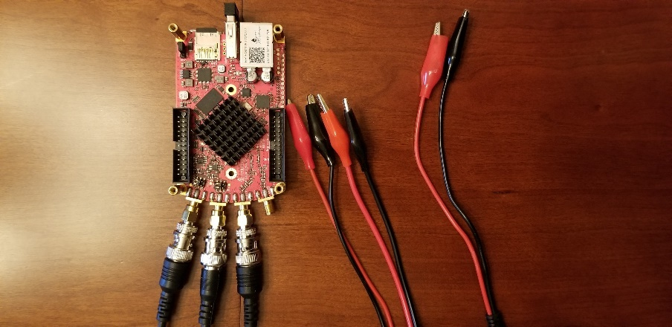

Fig. 1: Red Pitaya hardware configuration

## A quick introduction to diodes

Diodes are a semiconductor device that is formed by a PN junction. The current-voltage (I-V) relation of the device can be described by the Ideal (Shockley) diode equation:

Where is the Boltzmann constant, is the temperature in Kelvin, is the absolute value of the charge of an electron in Coulombs, and is the reverse saturation current in amperes. When , the argument to the exponent becomes very small, and . This makes . Conversely, when /q, , and thus . This exponential relationship is obviously non-linear, and can be made explicit by taking the taylor series of the exponential function:

Plugging this into the ideal diode equation gives:

This nonlinear behavior can be exploited for many applications. The diode symbol is shown below, and has an anode and cathode ends. This is reflected in the package by a stripe on the end of the package that mirrors the line in the diode symbol.

(<https://en.wikipedia.org/wiki/Diode#/media/File:Diode_pinout_en_fr.svg>)

1n914 diode with Cathode bar on right

# Tasks / Measurement

## Half bridge rectifier

Build the Single stage RC circuit shown in Fig. 2, with ,.

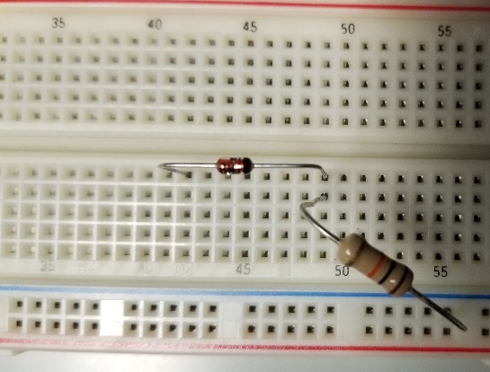

Fig. 2: (left) schematic of the single stage RC circuit, (right) implementation on breadboard

### Analysis

Oftentimes in analysis for a nonlinear systems, we choose to *linearize* the system about a specific operating point. This leverages the fact that for a small perturbation , the series expansion of a nonlinear function will be primarily linear for small . This comes from the calculation of the powers of ; for instance,

If , then

where is some error term. Applying the same logic to the ideal diode equation gives us the response.

Rearranging to subtract out the original current ,

Calling

Applying a Taylor expansion on all terms

Cancelling like terms being subtracted in the brackets gives

Finally applying the approximation and cancelling the resulting terms

At this point, the perturbation can be make to look like ohm’s law, and thus the perturbation is linear in behavior. This is equivalent to approximating the I-V curve of the diode as a tangent line approximation, and is a theme that is used extensively in engineering and applied mathematics.

1. Using the above linearization, what does the frequency response of the half bridge circuit look like?

### Measurement

Using the Red Pitaya’s Bode Analyzer tool, measure the frequency response () as described in the previous lab. Keep in mind that for this circuit, we stated that the amplitude must be small. Set the DC bias to > 0.6V to ensure the diode is forward biased while testing.

1. Show the plot of the measurement below:
2. Try making the amplitude larger and see what occurs. Find a point at which the behavior is no longer linear

Using the Red Pitaya’s Bode Oscilloscope & Spectrum analyzer tools, measure the large signal response to a sinusoid:

* With DC Bias of 0.7V, and amplitude 0.1
* With DC bias of 0V, and amplitude 1V

1. Comment on the Spectral content of the output signal when compared to the input signal.
2. Show a plot of the both the time waveforms and frequency domain.

### Comparison

Respond to the following questions:

1. Find the -3dB point in the circuit, and compare this value to the one you previously calculated.