ECE2170: Measuring the Frequency response of LTI systems with the Red Pitaya

# Goals of this lab

* Perform analysis on simple LTI systems
* Measure frequency responses for simple LTI systems
* Use the knowledge of LTI systems to measure real world values of physical components
* Demonstrate the stacking nature of LTI systems

# Background

## LTI systems

In general, a Linear system is a system that takes and input , and produces an output , that can be defined by a series of linear operators. Recall a linear operator is an operation that satisfies the principles of scalar multiplication and superposition. More mathematically, for vectors , scalars , the operator is linear if:

is satisfied. Examples of linear operators are:

* Differentiation/Integration
* Convolution
* Gradient/Divergence/Curl
* Laplace/Fourier transforms

Note that if there are multiple Linear systems, their cascaded effect can be described by composing each subsequent system with the output of the other. This is equivalent to combing each of the operators the systems are implementing and forming a compound operator.

Time invariance is the property that for a given system, if is the output of the system when given an input , then applying a delayed input will produce , a delayed version of . In the Time domain, this system has an impulse response and relates , by the relation:

Where is the convolution operation. The act of convolution can be difficult, so it is oftentimes more convenient to operate in another domain through some sort of transformation. A common transform is the Fourier transform, whereby a time domain signal is represented in the frequency domain. A consequence of the transform is the convolution operation is now reduced to multiplication.

Where is now the transfer function or frequency response of the system. Canonically, the transfer function is written as:

Every LTI system can be described by a given transfer function, with various systems being formed by various coefficients . In this lab, we will form a small number of systems with real components, and examine their behaviors.

## Materials

For this lab, you will need:

* 1x Red Pitaya
* 3x SMA to BNC adapters
* 3x BNC to alligator clamp cables
* 1x Breadboard
* 1x package of passive components

Connect the cables to the Red Pitaya via the adapters as shown in Fig. 1, noting that we need IN1,IN2, and OUT1 connections.

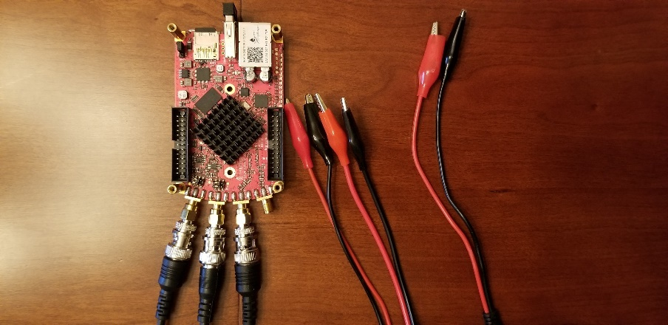

Fig. 1: Red Pitaya hardware configuration

## A quick introduction to Breadboards and Passive components

### Breadboards

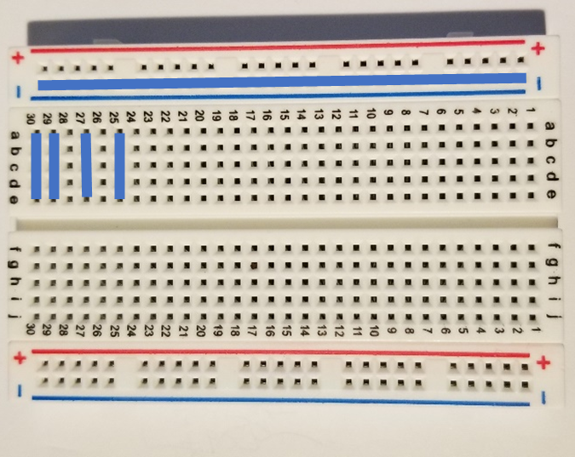

Bread boards are arrays of metal contacts internally tied together on a row wise basis (a,b,c,d,e) that are electrically separated on the columns (1,2,3,…,30). The exception to the rules are the bus bars on the extreme sides of the breadboard, where the entire row of the (-,+) rows are all electrically connected together. This is useful when using common terminals that are used through the circuit (as in the case of common, ground, or power supply nodes.

### Passives

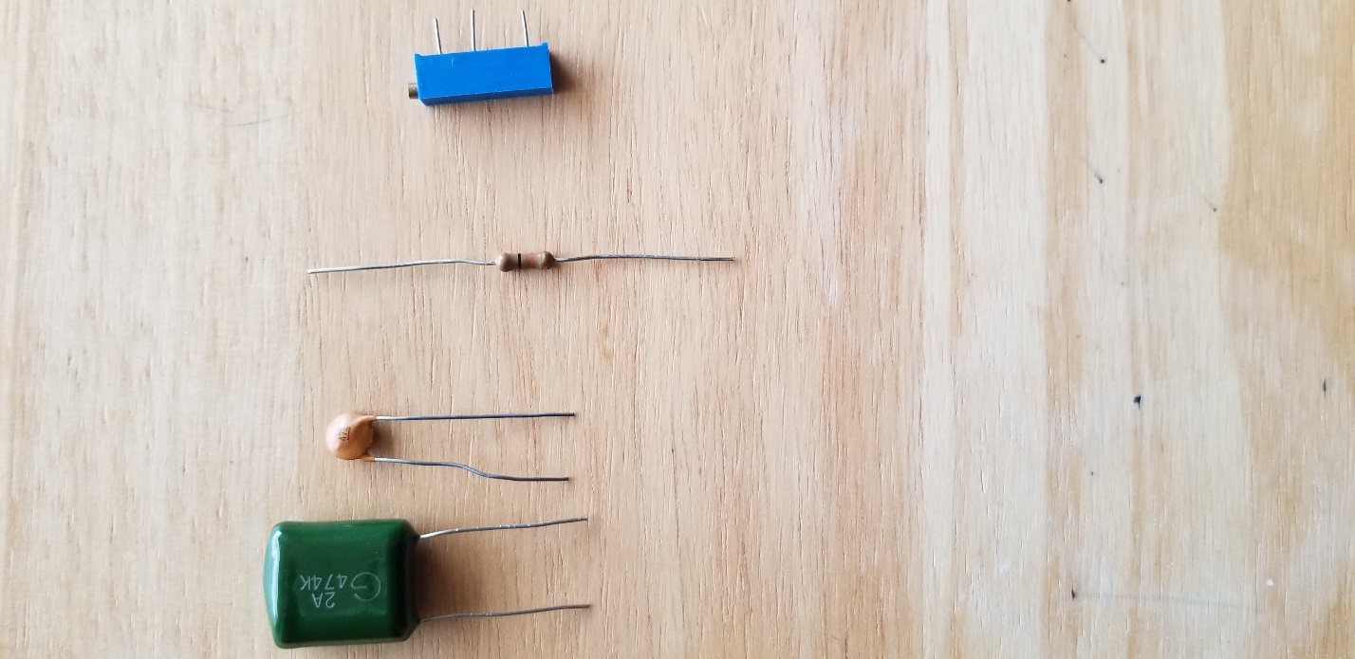

#### Resistors

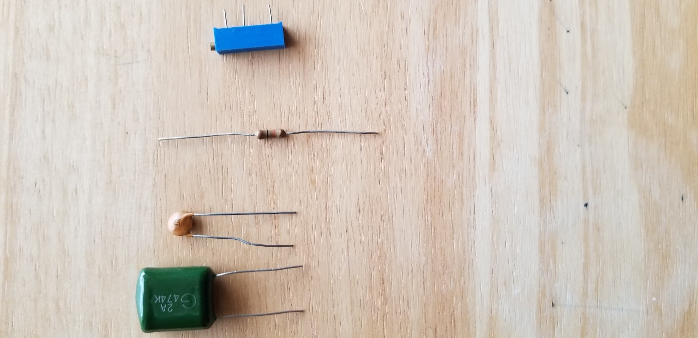

Resistors are a general element that obey Ohm’s law:

Where is the resistance measured in Ohms (V/A) is a measure of the resistance to current flow. These are frequency independent devices.

#### Capacitors



Capacitors have the Current-voltage relation:

Where is the capacitance measured in Farads (V/m). Capacitors have the impedance:

#### Potentiometers

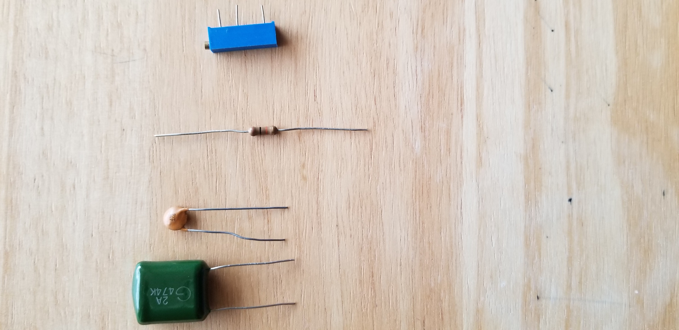

Potentiometers are three terminal devices consist of a resistor and a sliding contact that effectively breaks the resistor into two separate resistances. Depending on the contact location, the proportion of the total potentiometer resistance is distributed to each branch.

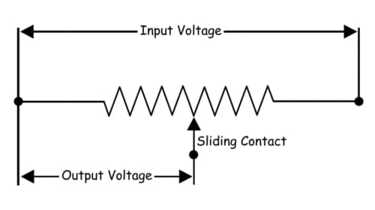

From: <https://www.electrical4u.com/potentiometer/>

# Tasks / Measurements

## Single stage RC circuit – 1

Build the Single stage RC circuit shown in Fig. 2, with ,.

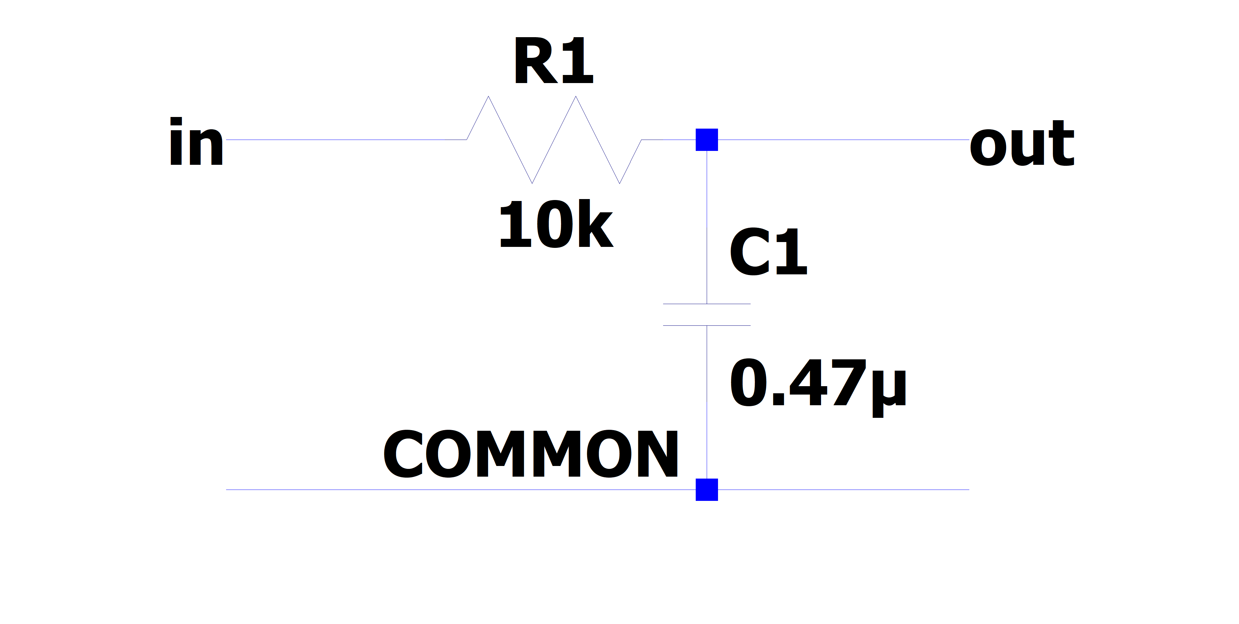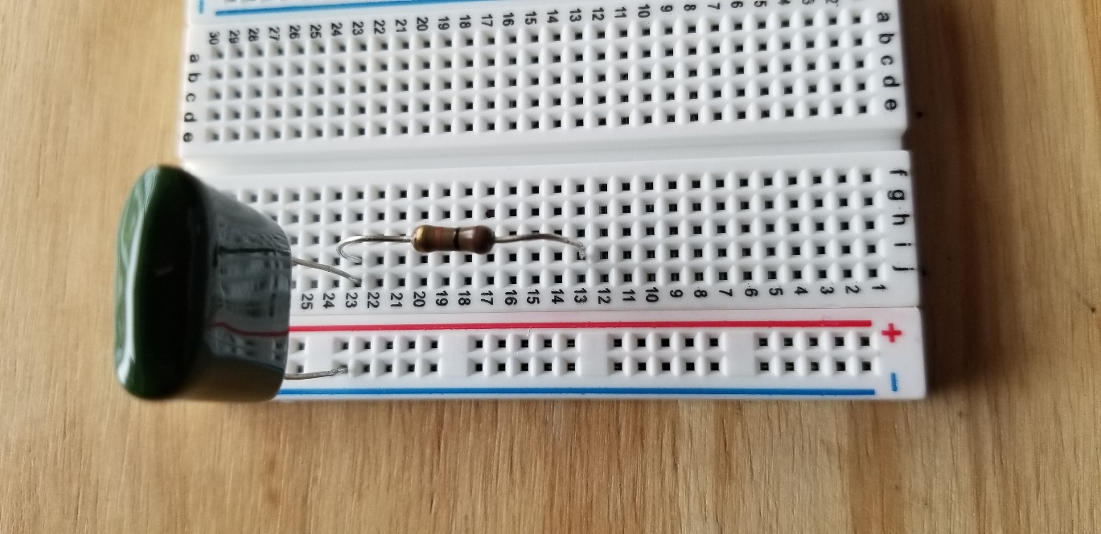

Fig. 2: (left) schematic of the single stage RC circuit, (right) implementation on breadboard

### Analysis

The claimed transfer function of this circuit is

Where is the imaginary unit.

1. What is the magnitude of the transfer function?
2. What is the phase response of the circuit?
3. What class (low-pass, high-pass, band-pass, band-stop) of filter is this? (This is equivalent to asking what happens to as gets lower or higher?)
4. At what frequency does ? (This corresponds to the so-called “half power point” where the ratio of the input to output power is 2 (-3dB) – The circuit drops half of the total power) This value is generally referred to the “cutoff frequency” or “-3dB frequency” and is represented by .
5. (optional) What would happen if I swapped the input and output ports?   
   (Hint: is there any current flowing through the resistor?)

### Measurement

Using the Red Pitaya’s Bode Analyzer tool, measure the frequency response ().

1. Connect the Red Pitaya to the circuit, also known as the Device Under Test (DUT)), as shown below

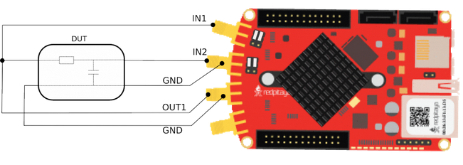

(from : <https://redpitaya.readthedocs.io/en/latest/appsFeatures/apps-featured/bode/bode.html>)

1. Connect to the Red Pitaya and select the Bode Analyzer tool.

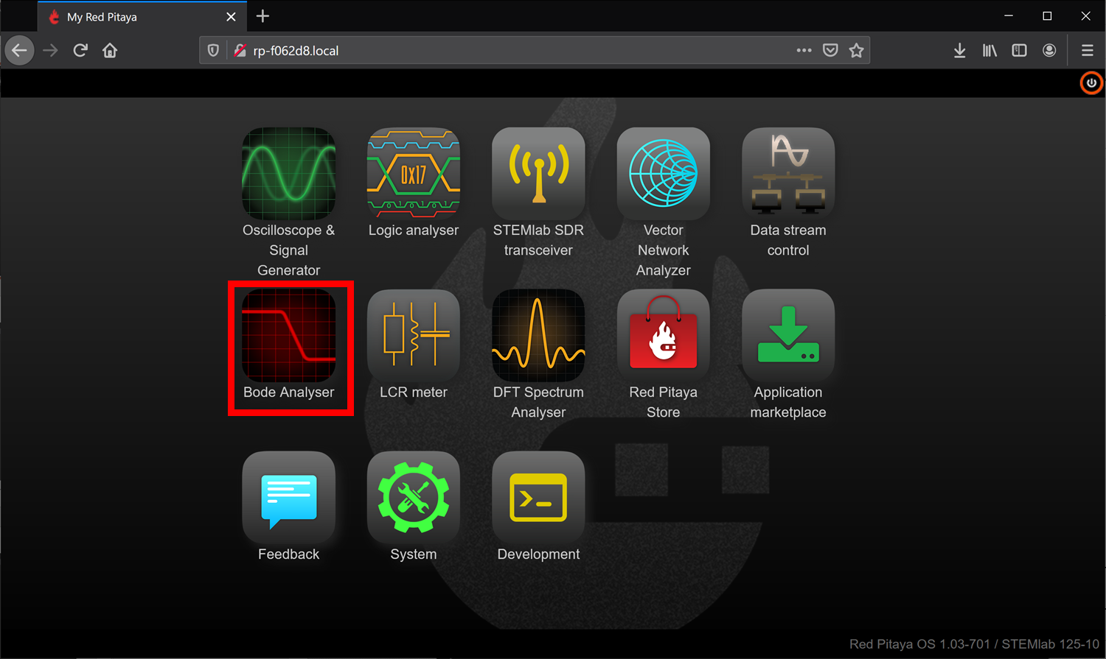

A more detailed description of the Bode analyzer can be found here: <https://redpitaya.readthedocs.io/en/latest/appsFeatures/apps-featured/bode/bode.html>

1. Click on the settings box to access the sweep settings

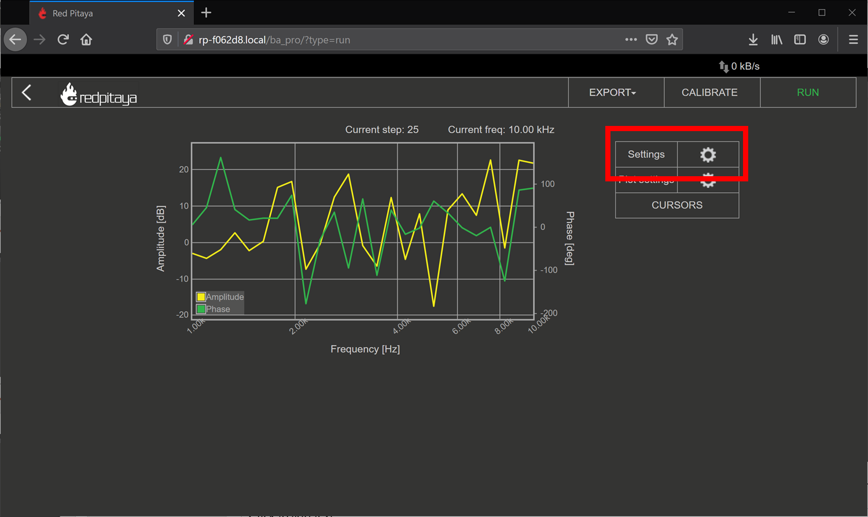

1. Configure the settings as shown below, we will find new sweep values as we go on, but these should be safe values to try

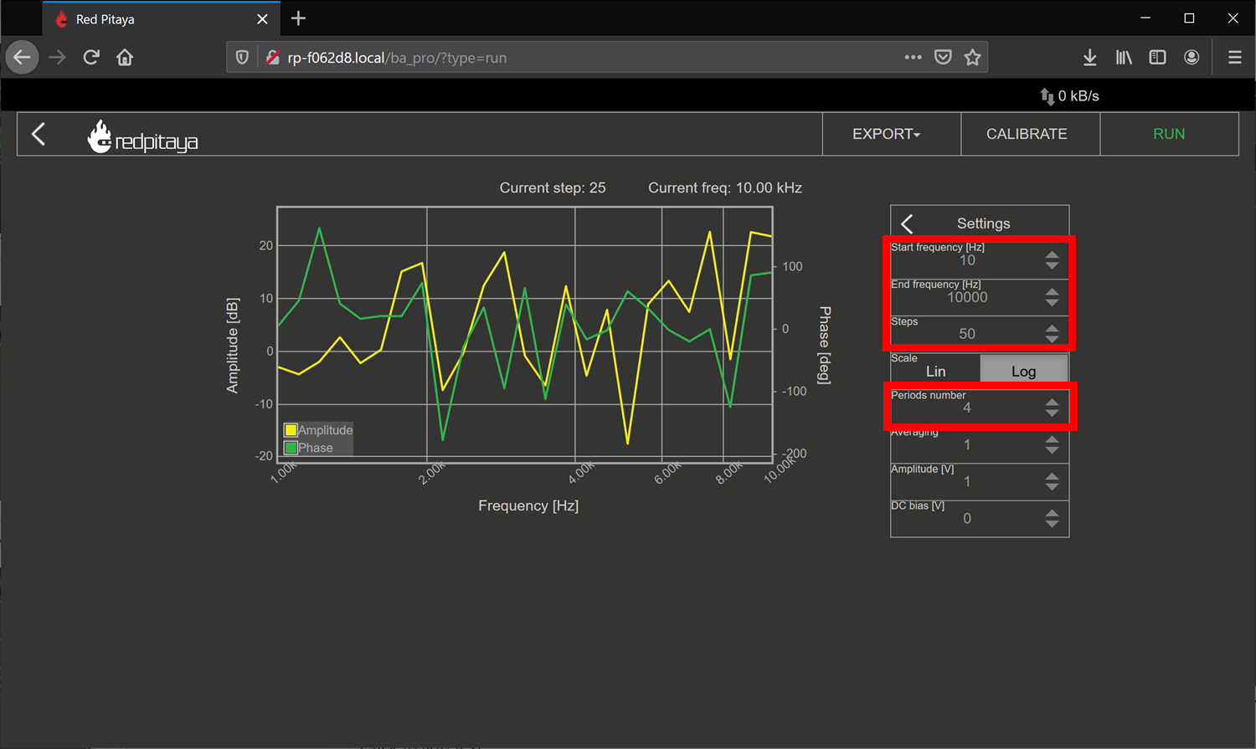

1. Click RUN – The sweep can take awhile to complete.

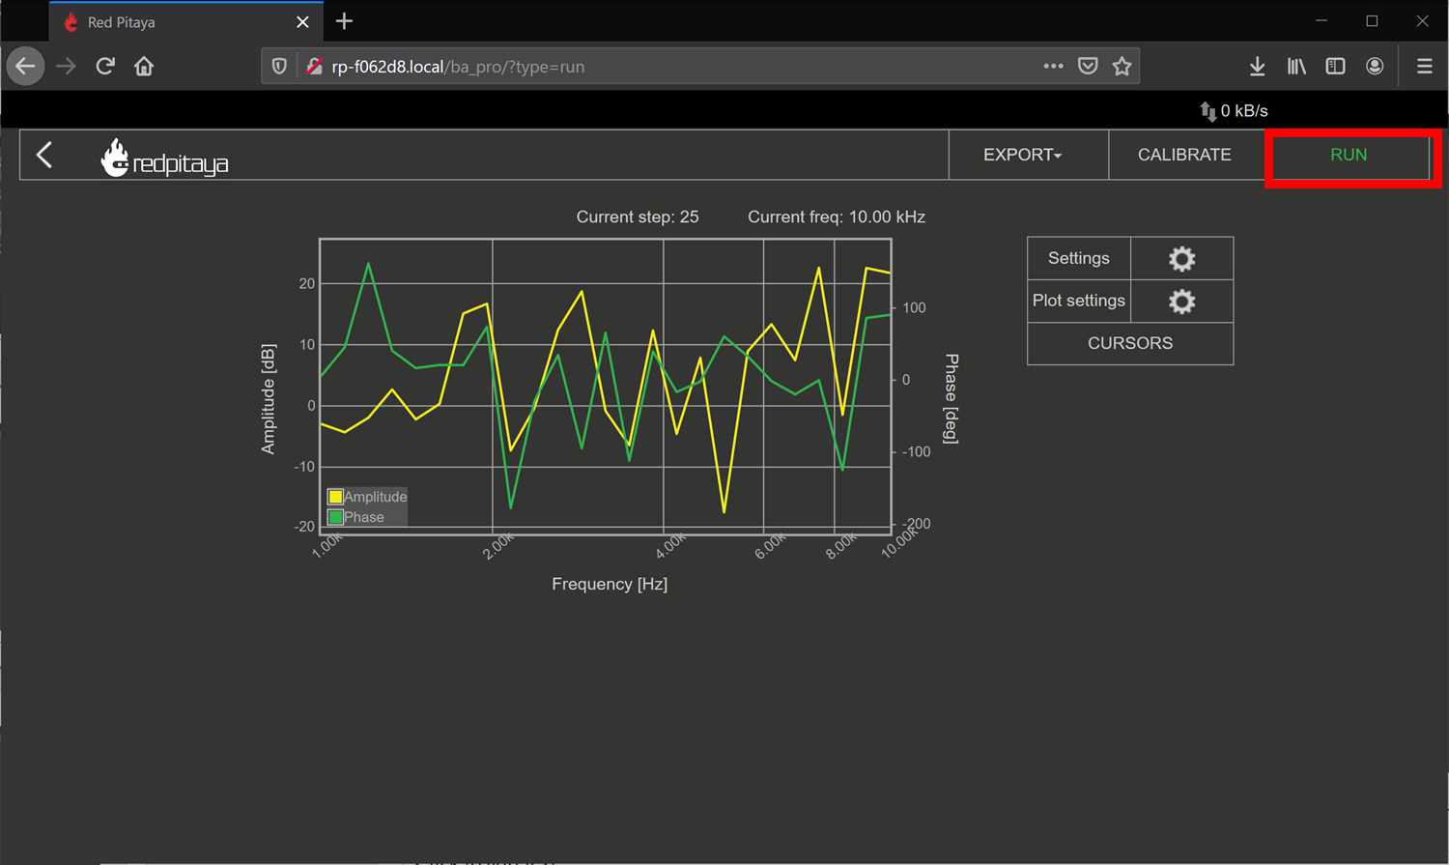

1. To export data: click the Export tab, and either select Graph for a PNG of the chart, or CSV for the raw CSV data of the plot.

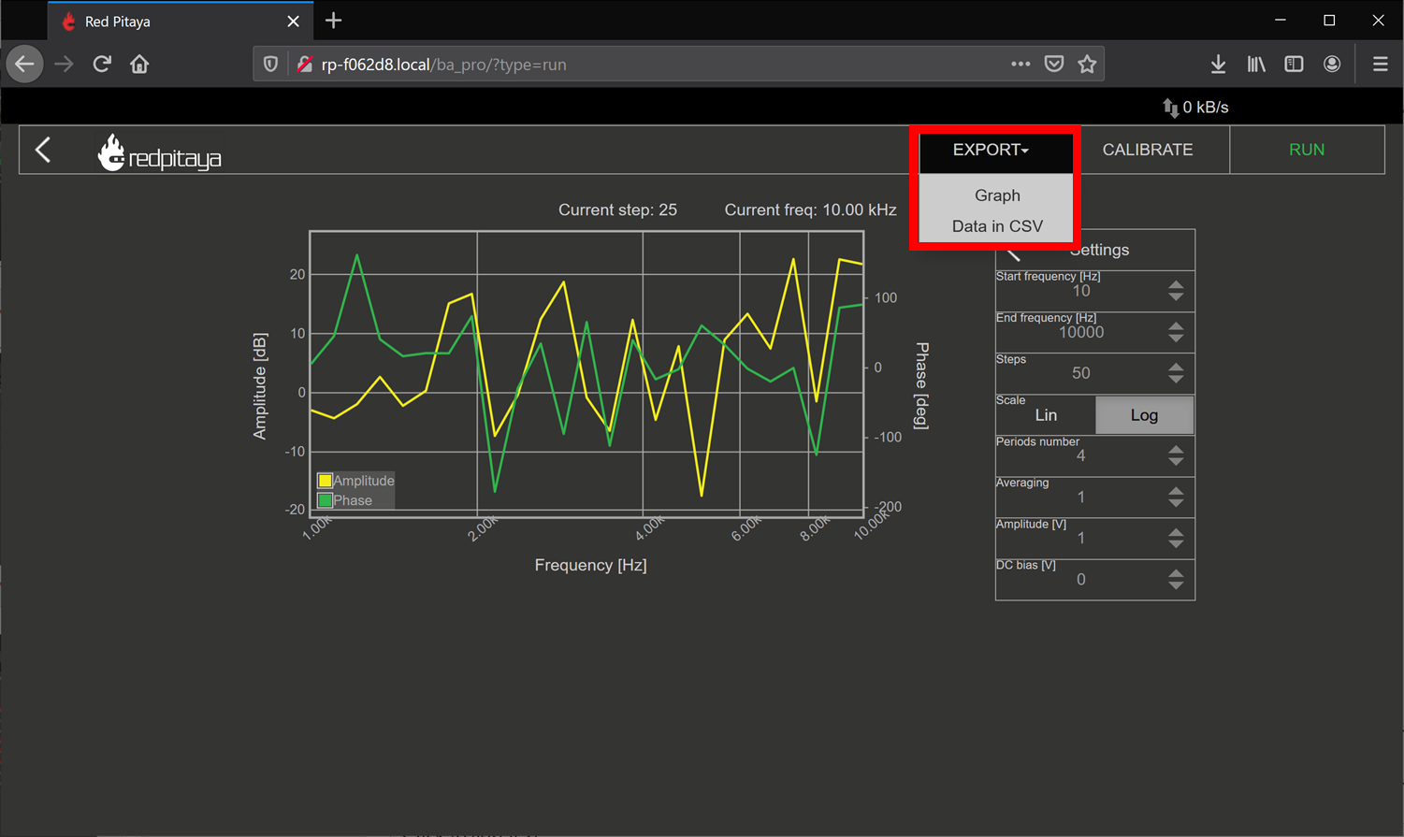

1. Show the plot of the measurement below:

### Comparison

Respond to the following questions:

1. Does the shape of the frequency response match your expectation from the analysis? Is there any point that stands out as odd?
2. Find the -3dB point in the circuit, and compare this value to the one you previously calculated.

## Single stage RC circuit – 2

Build the Single stage RC circuit shown in Fig. 3, with ,.

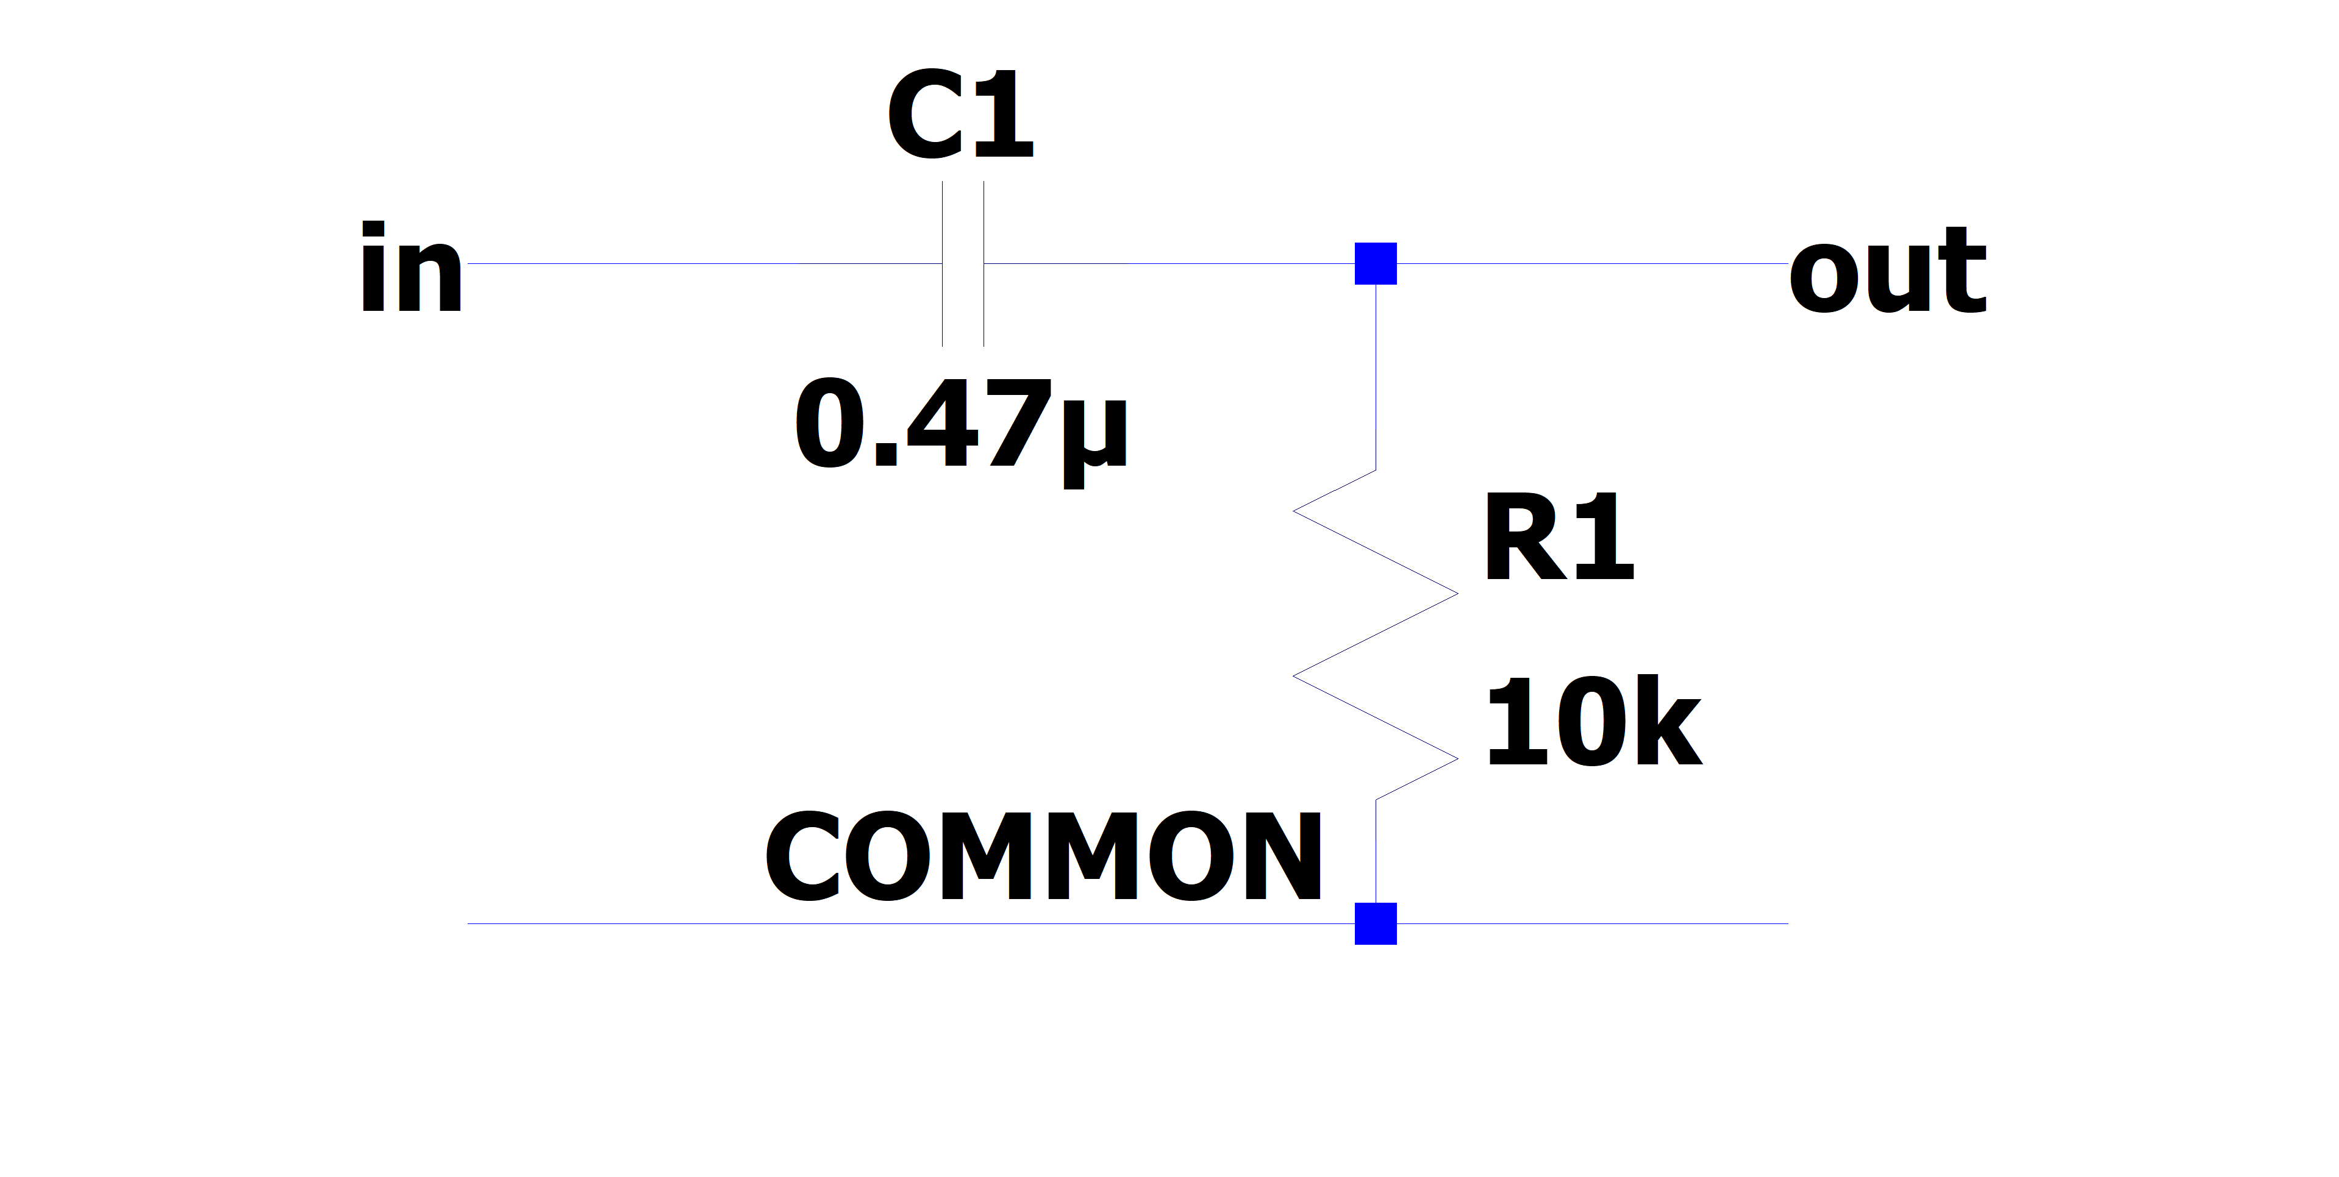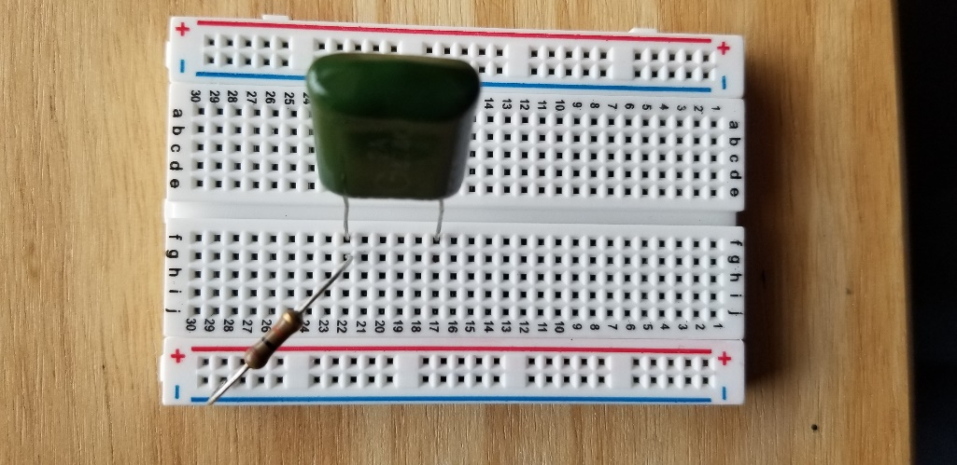

Fig. 3: (left) schematic of the single stage RC circuit, (right) implementation on breadboard

### Analysis

The claimed transfer function of this circuit is

Where is the imaginary unit.

1. What is the magnitude of the transfer function?
2. What is the phase response of the circuit?
3. What class (low-pass, high-pass, band-pass, band-stop) of filter is this?
4. What is the -3dB frequency?

### Measurement

Using the Red Pitaya’s Bode Analyzer tool, measure the frequency response () as described in section ‎3.1.2.

1. Show the plot of the measurement below:

### Comparison

Respond to the following questions:

1. Does the shape of the frequency response match your expectation from the analysis? Is there any point that stands out as odd?
2. Find the -3dB point in the circuit, and compare this value to the one you previously calculated.

## Single stage RC circuit – Unknown parameter estimation

Build the Single stage RC circuit shown in Fig. 4, with the potentiometer and . Use another resistor to provide electrical contact. Ensure that the potentiometer pins used are the two furthest pins, as this will be the total resistance of the device.

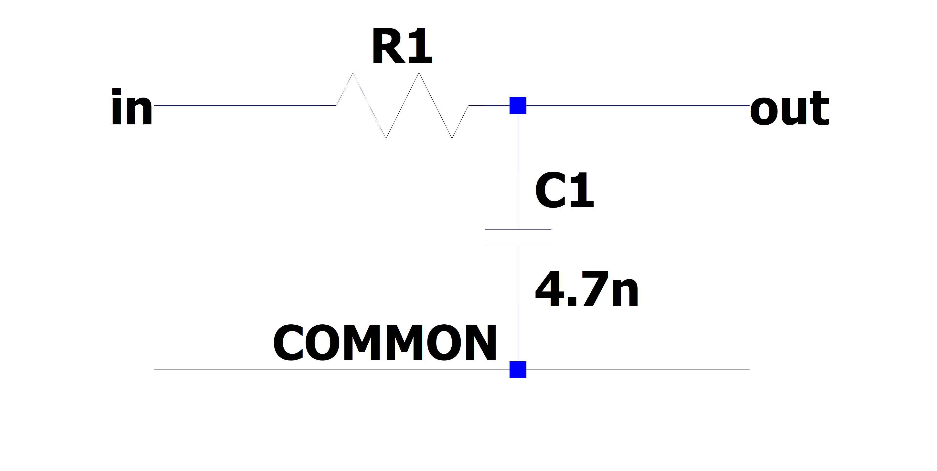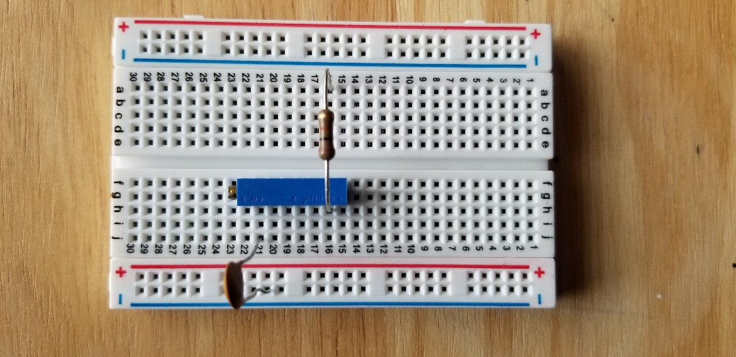

Fig. 4: (left) schematic of the single stage RC circuit, (right) implementation on breadboard

### Analysis

The claimed transfer function of this circuit is the same as in ‎3.1 (reprinted here for courtesy)

Where is the imaginary unit. However now the value of is unknown. Since we already know the expected behavior of the system, we can estimate the value of by measuring the transfer function again.

1. Derive the expression for the -3dB frequency as a function of .

### Measurement

Using the Red Pitaya’s Bode Analyzer tool, measure the frequency response () as described in section ‎3.1.2. Pay special attention to include the cutoff frequency in the sweep.

1. Show the plot of the measurement below:

### Comparison

Respond to the following questions:

1. Use the expression you derived to calculate the value of from the measured value of .
2. The previous analysis all presumed we knew the value of perfectly. In reality, the values of there are only approximately known.
   1. If the capacitance value can vary , what is the bounds on the error of the calculated value of ?
   2. If the frequency value can vary , what is the bounds on the error of the calculated value of ?
   3. If the both as above simultaneously, what is the total bounding on the error of the calculated value of ? (Hint: This should be a rectangular area)
3. (Optional) In the same line of thought, assume that the values of are described statistically by gaussian distributions with mean and variances provided below:
   1. What is the resulting probability distribution of ?

## Cascading filters – Repeated stages

Build the RC circuit shown in below, with ,.

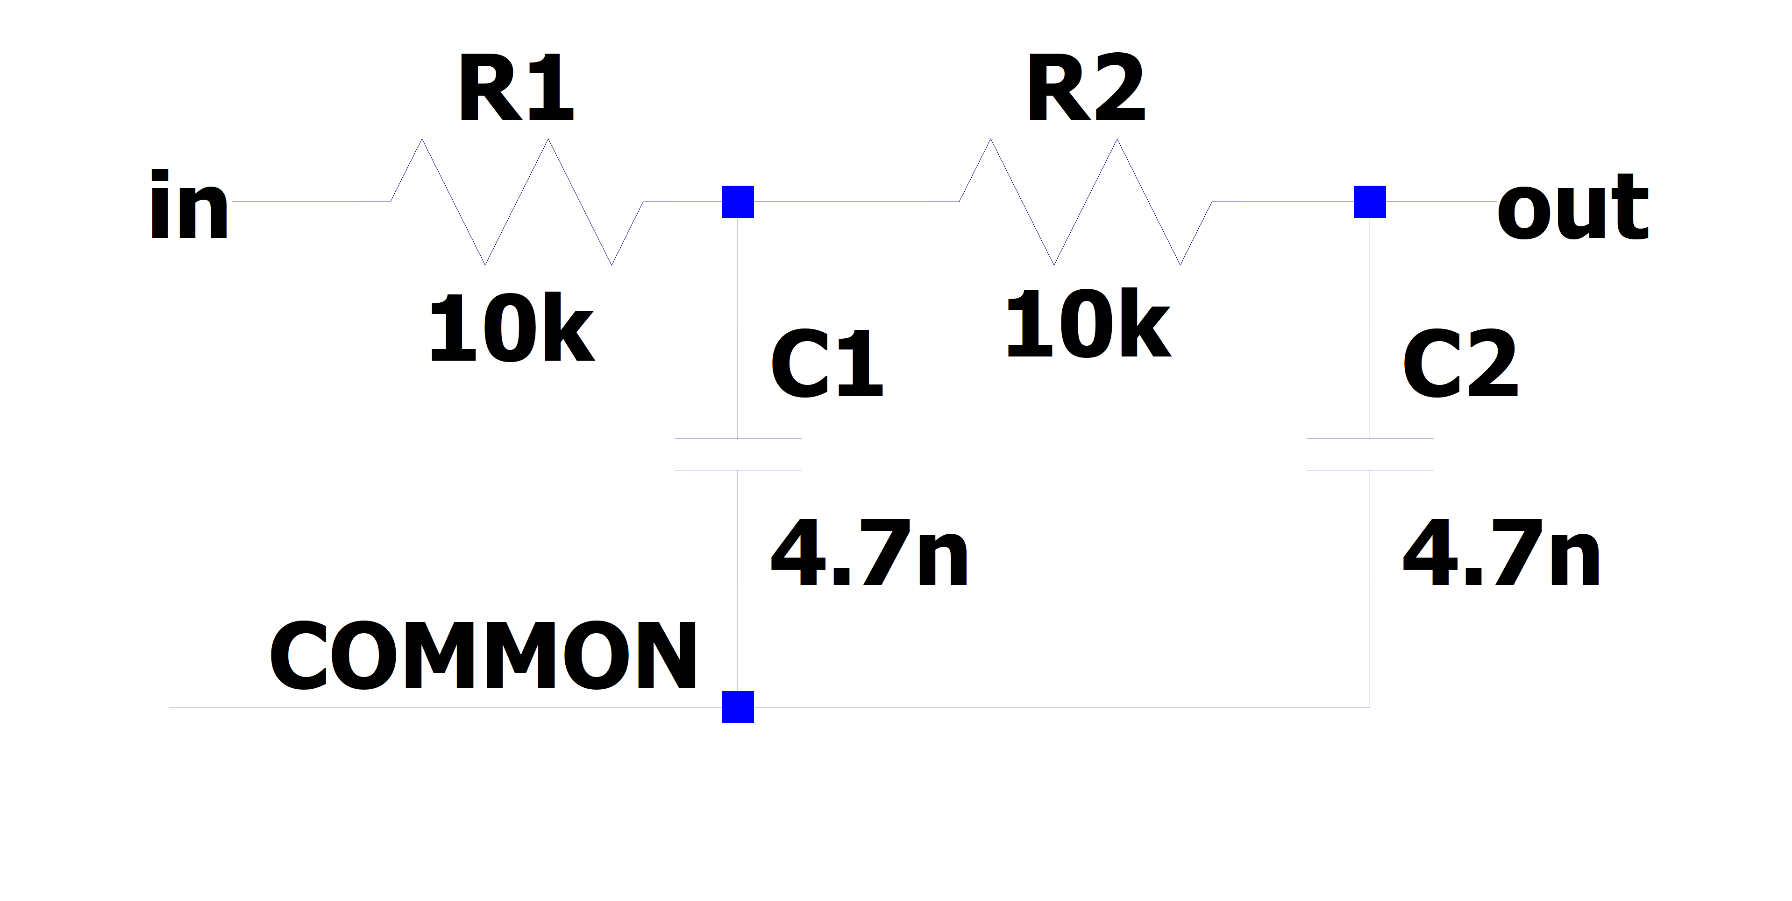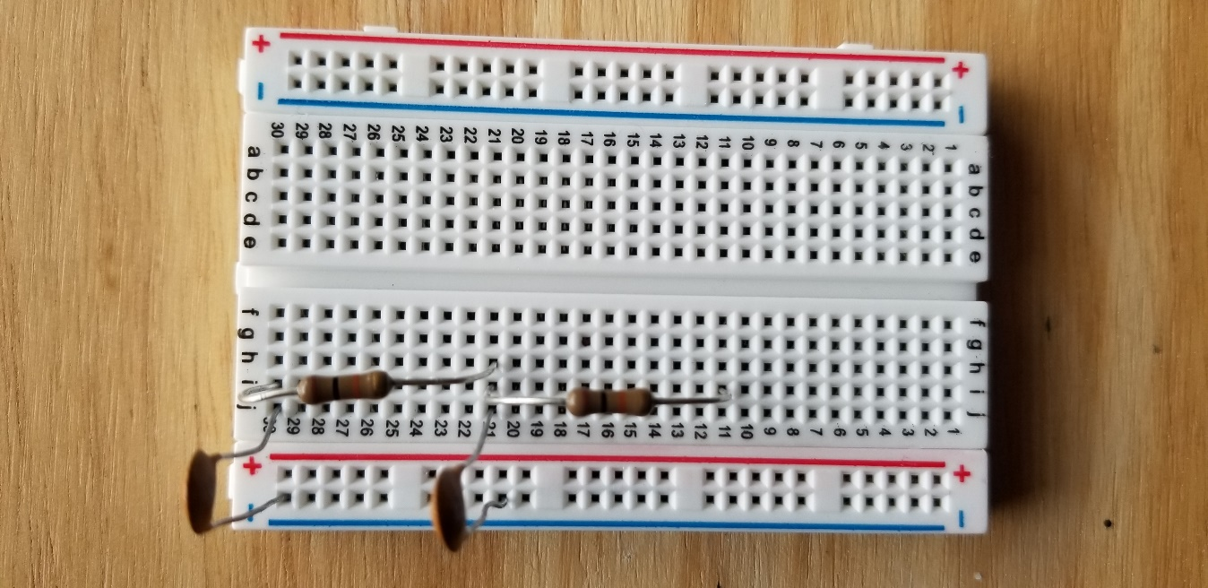

Fig. 5: (left) schematic of the single stage RC circuit, (right) implementation on breadboard

### Analysis

The claimed transfer function of this circuit is

Where is the imaginary unit.

1. What is the magnitude of the transfer function?
2. What is the phase response of the circuit?
3. What class (low-pass, high-pass, band-pass, band-stop) of filter is this?
4. What is the -3dB frequency?

### Measurement

Using the Red Pitaya’s Bode Analyzer tool, measure the frequency response () as described in section ‎3.1.2.

1. Show the plot of the measurement below:

### Comparison

Respond to the following questions:

1. Does the shape of the frequency response match your expectation from the analysis? Is there any point that stands out as odd?
2. Find the -3dB point in the circuit, and compare this value to the one you previously calculated.
3. This circuit can be viewed as two separate 1st order filters (see section ‎3.1) cascaded. What would the expected transfer function of such an arrangement look like? How different is this the expression you would expect from two ideal LTI systems?

## Cascading filters – variable stages

Build the filter shown below, with using the potentiometer as constant resistance. Once again, use the other 10K resistor as an electrical contact.

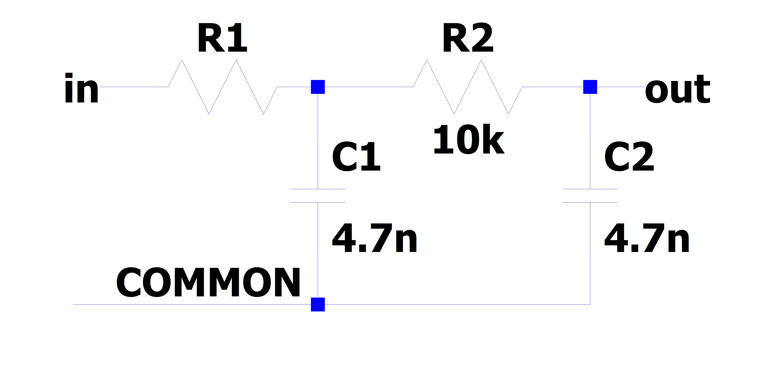 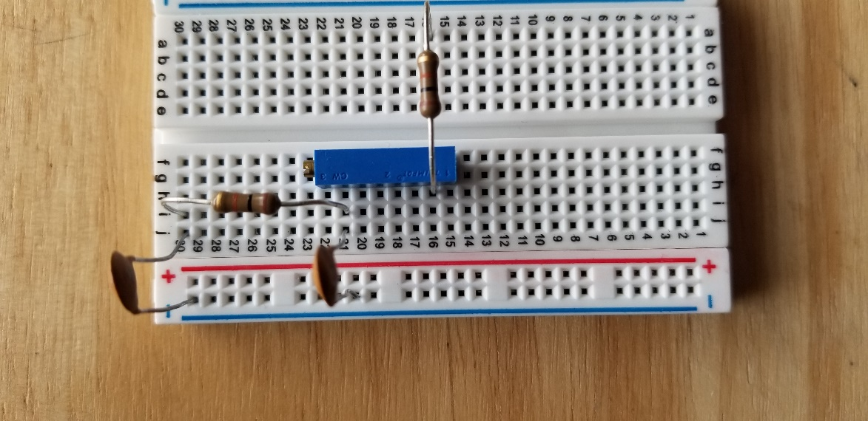

Fig. 6: (left) schematic of the single stage RC circuit, (right) implementation on breadboard

### Analysis

The claimed transfer function of this circuit is

Where is the imaginary unit.

1. What is the magnitude of the transfer function?
2. What is the phase response of the circuit?
3. What class (low-pass, high-pass, band-pass, band-stop) of filter is this?
4. What is the -3dB frequency?

### Measurement

Using the Red Pitaya’s Bode Analyzer tool, measure the frequency response () as described in section ‎3.1.2.

1. Show the plot of the measurement below:
2. (Optional) Try sweeping from 10Hz to 1MHz. Is there anything strange that happens to the frequency response? Capture the frequency response, and describe what seems to happen to the transfer function.

### Comparison

Respond to the following questions:

1. Does the shape of the frequency response match your expectation from the analysis? Is there any point that stands out as odd?
2. Find the -3dB point in the circuit, and compare this value to the one you previously calculated.