ECE2170: Modulation with the Red Pitaya

# Theory

## Mixing

To achieve this modulation, we can view the mathematical result of multiplying two periodic waveforms. For this analysis case, we will employ two sinusoids.

Multiplying these two is made simple by invoking the well known trig identity:

thus allowing:

This shows that:

1. We generate data at the sum and difference frequencies
2. Phases add directly
3. The amplitude/energy of the resulting data is shared from both waveforms

In most mixing applications, the results of a mixer are then filtered to only include either the sum or the difference frequency.

## AM modulation

Amplitude modulation is one of the simplest forms of modulation. This involves using a message signal (bandlimited to ) to modulate the amplitude of a faster “carrier” signal at . For simplicity, we will take the carrier to have no phase (this is justified by (3), where we can see that the mixed results simple add phase, and we can simply define ), and give the modulated signal some phase .

### Dual Side Band (DSB) modulation

Employing the simplest mixing, we simply multiple the carrier (denoted ) by the message signal (denoted ). This makes the resulting signal

This is what is known as Dual Side Band (DSB) or suppressed carrier modulation.

### Amplitude Modulation

A more traditional AM modulation method for AM modulation employs a slightly modified version of DSB modulation. This time, the modulating signal is 1) scaled by the carrier amplitude, and 2) given a DC offset. This makes the new modulation function take the form

This makes the modulated signal simply . This can be shown with some more clever trig identities to take the form

#### Sidenote: Modulation Index

Since there are now two terms, a carrier and the encoded message signal, we can consider the case of analyzing the peak of the message signal compared to the peak of the carrier. This ratio is known as the modulation index , and describes the modulation “strength” of the message onto the carrier.

Full strengths modulation corresponds to a 100% index, and means that potential peaks of the carrier can be suppressed into a null. This parameter is not so important for this lab, but will be of interest to the analysis of communication systems in a future course.

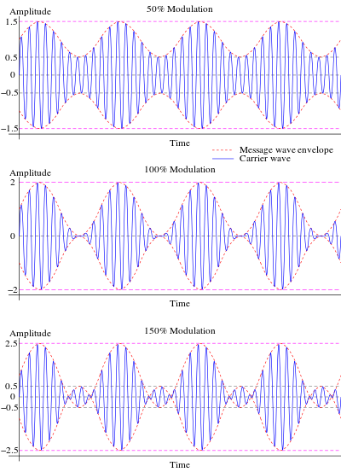

Figure : Modulation Index visualized. Credit: Wikipedia (<https://en.wikipedia.org/wiki/Amplitude_modulation#Modulation_index>)

## Normalized Frequency:

After the act of sampling, it becomes convenient to rescale (normalize) frequency w.r.t. the sampling frequency. This is done by the relation

Where This representation is oftentimes used in discrete time systems as it allows for the consideration of systems in reference to the total bandwidth of the discrete system.

# Tasks/Questions:

## Theory

1. Why in the analysis of mixing, were two sinusoids used? (Hint, sinusoids are what for the space of periodic functions?)
2. Why is the carrier being a sinusoid preferrable from a transmission perspective?
3. In both described AM schemes (DSB, AM w/modulation index), is there a way to reduce the total bandwidth of the system anymore? (Hint, do you need both sides of a spectrum to retrieve a signal if you know the signal is real valued?)
4. It was stated in the theory, that for AM, usually . Why would this be true, and why would one want to be even larger. For example, FM radio operates on a carrier of , but the bandwidth of audio signals is only (as was demonstrated last lab).
5. Why is the carrier generally a very powerful signal in real systems? (Hint: how far are you from the radio tower when you listen to the radio? As all signals travel, they will spread out unless coerced otherwise)

## Experiment

1. Set the frequency of the message signal to 0.1. Show a plot of the acquired waveform

What does a normalized frequency mean, and why does it introduce odd behavior into the observed waveforms?

1. What happens when the message signal frequency is the same size or greater than the carrier frequency?
2. Use a message signal that is not a pure sinusoid (e.g. use anything that is a superposition of sinusoids), show the resulting spectrum, and comment as to the bandwidth of the modulated signal.
3. Use a carrier signal that is not a pure sinusoid (e.g. use the square function), show the resulting spectrum, and comment as to the resulting signal strength in any one peak when compared to a pure sinusoidal carrier.
4. Demonstrate aliasing with the modulated signal. This will involve you setting the message signal to have frequency content that passes the sampling frequency when modulated by the carrier. Show a plot of the aliased content in the time domain, and the frequency domain.