ECE2170: Using the Red Pitaya for measuring properties of periodic waveforms

# Goals of this Lab

1. Demonstrate ability to use Oscilloscope, Signal Generator, and Spectrum Analyzer capabilities of Red Pitaya through GUI.
2. Configure Red pitaya to receive external inputs.
3. Perform measurements on a multitude of periodic waveforms

# Tasks / Measurements

Configure the Red Pitaya for a Loopback configuration (SMA cables tied between the outputs and inputs to the Red Pitaya) as shown in Fig. 1.

Fig. 1: Red Pitaya in Loopback Configuration

## Measure the Period of a waveform – Time Domain

Open the Oscilloscope & function Generator Application.

Configure the output of the red pitaya for a 1500Hz Sinusoid as shown in Fig. 2.

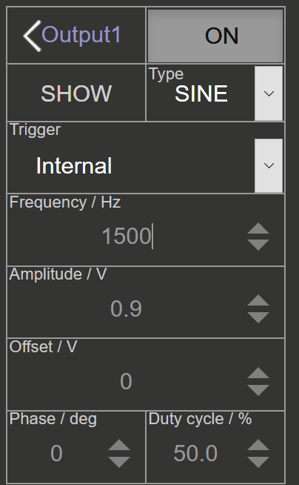

Fig. 2: OUT1 Configuration for measuring period/frequency

Configure the trigger for a negative edge trigger with zero level and normal trigger mode as shown in Fig. 3.

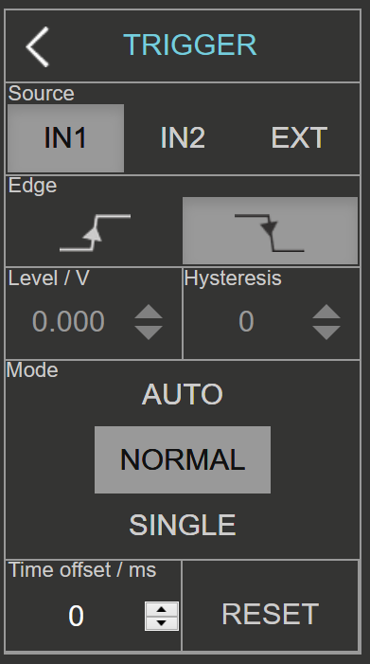

Fig. 3: Trigger Configuration

Enable OUT1. You should now see a figure close to the following

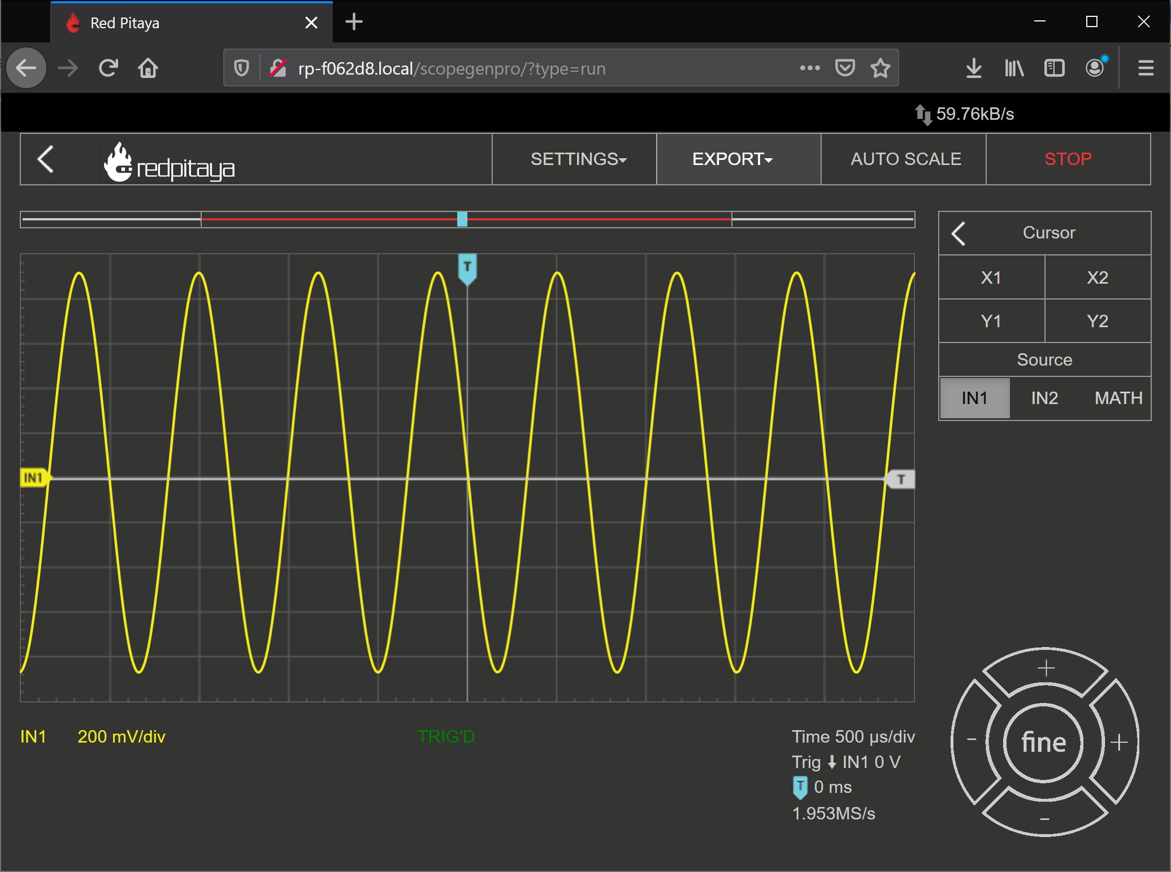

Fig. 4: Target output for 1500 Hz Sinusoid with negative edge triggering

To measure the period,

1. Select the “Cursor” box, and enable “X1”, “X2” options.
2. Drag each cursor to a common feature of the waveform (peak to peak, trough to trough)
3. Read off spacing between cursors. This is an approximate measure of the period

Period can also be measured by the red pitaya itself, under the meas command by selecting “Period” and “IN2”, and finally selecting “Done”. This is shown in Fig. 5.

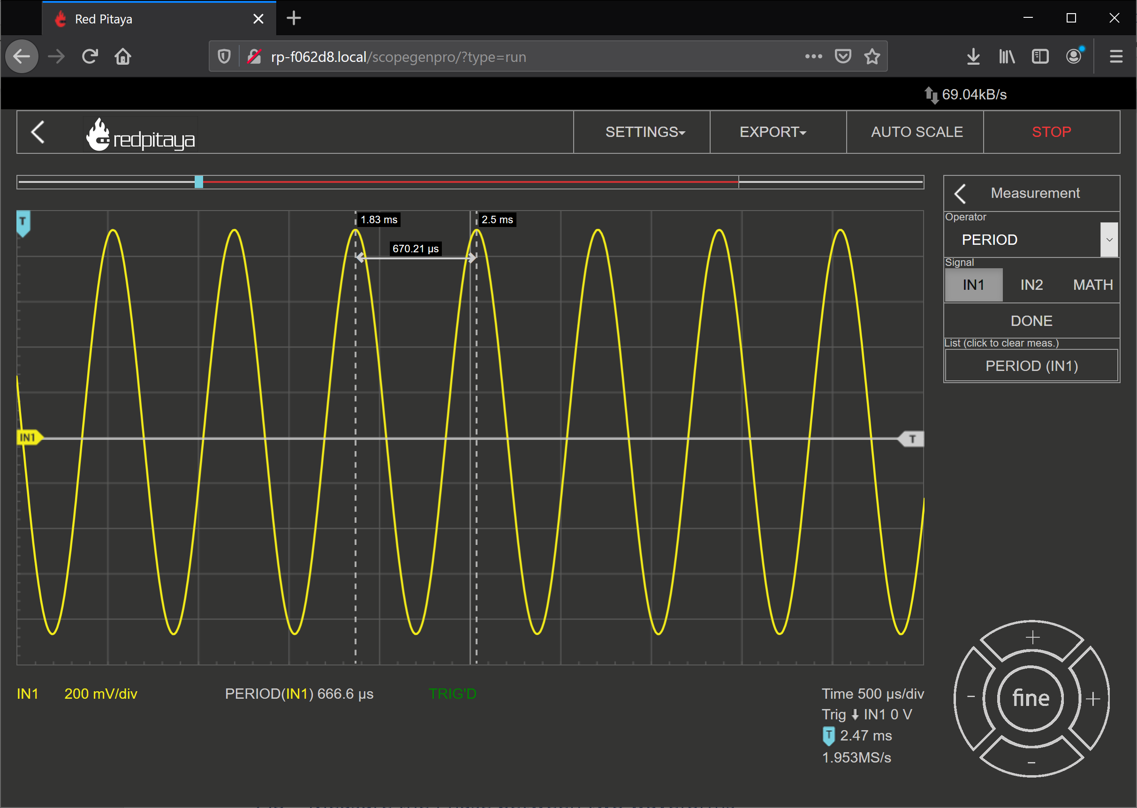

Fig. 5: Measured waveform vs Cursor measurement

## Measure the Fundamental Frequency of a waveform – Time Domain

To measure the fundamental frequency of a waveform, bring up the X1,X2 cursors, and select a single period of the waveform. From there one can use the relation

to estimate the frequency of the waveform.

Once again, the Red pitaya can also calculate this by selecting the “FREQ” measurement option in the “Meas” options as shown below.

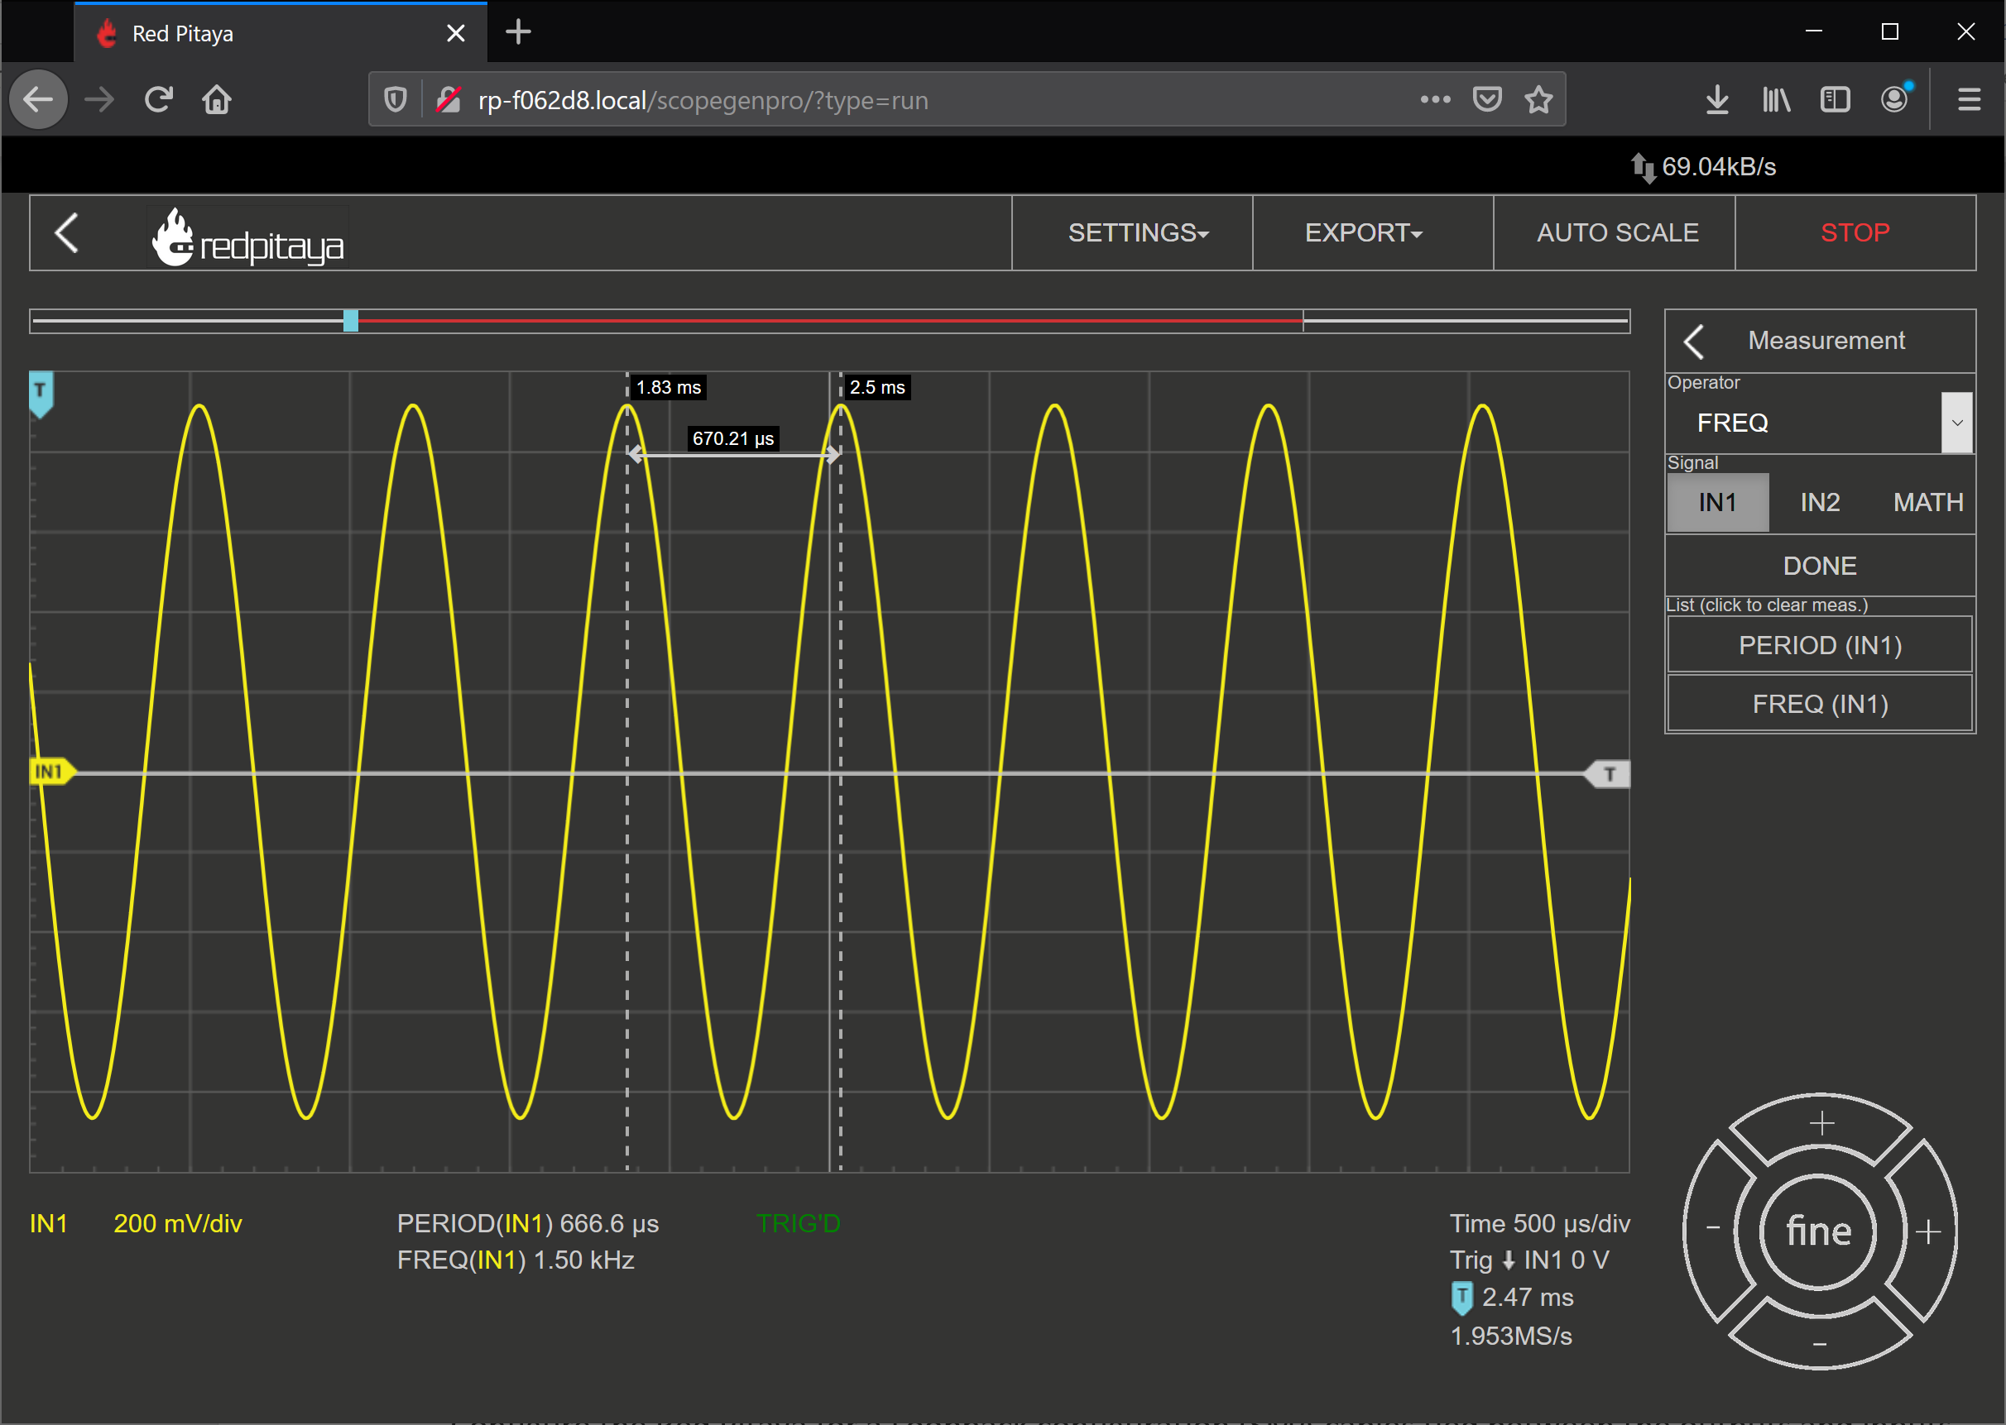

Fig. 6: Frequency Measurement added

## Measure the Phase between two waveforms – Time Domain

Select output 2, and select the second output to be a 1500 Hz sine wave with a 45 degree phase shift

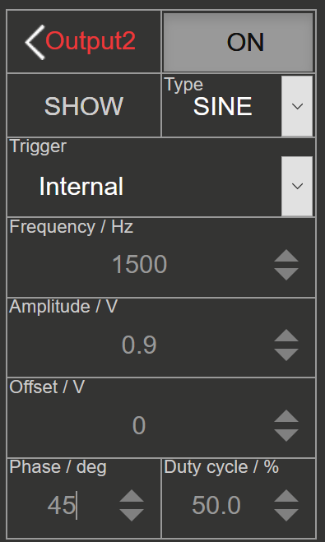

Fig. 7: Second channel configuration

Configure the trigger for a single shot acquisition as shown in Fig. 8.

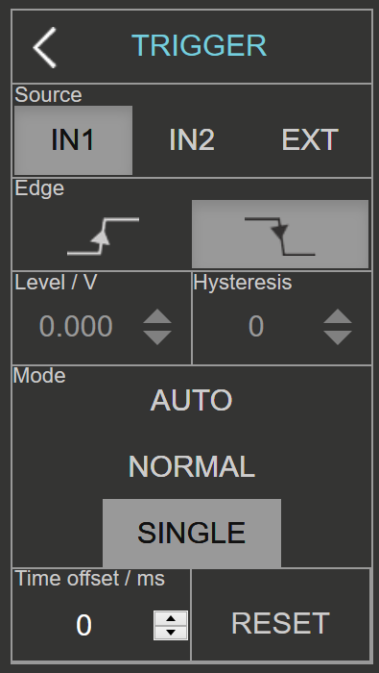

Fig. 8: Trigger configuration

Acquire a single capture, and measure the frequency and period of each waveform as previously described. Note that for the second channel, you may want to specify your cursors to track channel 2 in the cursor menu. To measure the Phase between waveforms, simply calculate the difference in time between two corresponding peaks between waveforms, and convert this to their corresponding difference in angular frequency. This can be calculated for signals of equal frequency with the relation

1. Analytically calculate the period of either waveform, and the time delay expected for the configured 45 degree phase shift between waveforms.
2. Set the output frequency of a OUT1 to 1000 Hz and trigger to normal or auto. What is the behavior that is observed? Comment as to the origin of the behavior, and a potential fix for the behavior. (hint, consider the greatest common divisor between the two frequencies)
3. (Take home) Repeat part 2, but for the frequency values of 3000Hz, and 1531Hz. What behavior is displayed here for each frequency? What are some potential ways to work around this problem? (hint, consider the greatest common divisor between the two frequencies, and alternative trigger modes)

## Measure the Spectrum of the waveform - Frequency Domain

Open the DFT Spectrum Analyzer Application.

Recreate the waveform employed in ‎2.1. For convenience, this is reprinted below:

1. Configure the output of the red pitaya for a 1500Hz Sinusoid as shown in Fig. 2.

Set the Span of the spectrum analyzer to 6.5 kHz.

Observe the location of the peak(s), and infer what this implies about the sinusoid’s fundamental frequency and its purity (harmonic content). Mention the relative strength between the various peaks in dB and in linear scales, knowing the relation between dB and linear scales in dBm is given by:

## Comparing Waveforms in the Time domain

Configure the Red Pitaya for a Loopback configuration (SMA cables tied between the outputs and inputs to the Red Pitaya) as shown in Fig. 1.

### Reference Case: Sine and Cosine

Set OUT1 and OUT2 to be sines of the same frequency of 1000Hz, with equal amplitude. Set OUT2 to have a phase of 90 degrees.

Fig. 9: Reference waveforms

1. Capture a screen shot of the resulting waveforms. Comment on any visible similarities or differences.
2. Try varying amplitudes/frequencies/phases of both channels and comment on the overall effects each variable does as observed in the time domain. Capture a screen capture that demonstrates each observable change, and clearly label what change was done between each
3. (Take Home) Drop the amplitude of OUT2 to 0.45 V (0.5x amplitude). How much does the waveform’s Peak-to-Peak value change by?

### Sine and Square

With the same setup as ‎‎2.5.1, change OUT1 to produce a SQUARE, as shown in Fig. 10.

Fig. 10: OUT1 Configured for SQUARE output

1. Capture a screen shot of the resulting waveforms. Comment on any visible similarities or differences.
2. (Take Home) Try varying amplitudes/frequencies/phases of both channels and comment on the overall effects each variable does as observed in the time domain. Capture a screen capture that demonstrates each observable change, and clearly label what change was done between each channel. For any parameters that do not produce visible changes, comment on why you believe this is so.
   1. Amplitude:
   2. Frequency:
   3. Phase:

### Sine and Sawtooth

With the same setup as ‎‎2.5.1, change OUT1 to produce a SAWU, as shown in Fig. 11.

Fig. 11: OUT1 Configured for SAWU output

1. Capture a screen shot of the resulting waveforms. Comment on any visible similarities or differences.
2. (Take Home) Try varying amplitudes/frequencies/phases of both channels and comment on the overall effects each variable does as observed in the time domain. Capture a screen capture that demonstrates each observable change, and clearly label what change was done between each channel. For any parameters that do not produce visible changes, comment on why you believe this is so.
   1. Amplitude:
   2. Frequency:
   3. Phase:

### (Take Home) Sine and Pulse Width Modulated (PWM) output

With the same setup as ‎‎2.5.1, change OUT1 to produce a PWM with a 10% duty cycle, as shown in Fig. 12.

Fig. 12: OUT 1 configured for PWM output

1. Capture a screen shot of the resulting waveforms. Comment on any visible similarities or differences.
2. (Take Home) Try varying amplitudes/frequencies/phases of both channels and comment on the overall effects each variable does as observed in the frequency domain. Capture a screen capture that demonstrates each observable change, and clearly label what change was done between each channel. For any parameters that do not produce visible changes, comment on why you believe this is so.
   1. Amplitude:
   2. Frequency:
   3. Phase:
   4. Duty Cycle:

## Comparing Waveforms in Frequency Domain

Configure the Red Pitaya for a Loopback configuration (SMA cables tied between the outputs and inputs to the Red Pitaya) as shown in Fig. 1. Open the DFT Spectrum Analyzer application. **This portion is equivalent to viewing all the waveforms in part ‎2.5 in the Frequency Domain.**

### Reference Case: Sine and Cosine

Set OUT1 and OUT2 to be sines of the same frequency of 1000Hz, with equal amplitude. Set OUT2 to have a phase of 90 degrees, as shown in Fig. 9.

1. Capture a screen shot of the resulting spectrums/spectrograms. Comment on any visible similarities or differences.
2. Try varying amplitudes/frequencies/phases of both channels and comment on the overall effects each variable does as observed in the frequency domain. Capture a screen capture that demonstrates each observable change, and clearly label what change was done between each
3. (Take Home) Drop the amplitude of OUT2 to 0.45 V (0.5x amplitude). How much do the peaks corresponding to this waveform shift by in dBm?

### Sine and Square

With the same setup as ‎‎2.5.1, change OUT1 to produce a SQUARE, as shown in Fig. 10.

1. Capture a screen shot of the resulting spectrums/spectrograms. Comment on any visible similarities or differences.
2. (Take Home) Try varying amplitudes/frequencies/phases of both channels and comment on the overall effects each variable does as observed in the frequency domain. Capture a screen capture that demonstrates each observable change, and clearly label what change was done between each channel. For any parameters that do not produce visible changes, comment on why you believe this is so.
   1. Amplitude:
   2. Frequency:
   3. Phase:

### Sine and Sawtooth

With the same setup as ‎‎2.5.1, change OUT1 to produce a SAWU, as shown in Fig. 11.

1. Capture a screen shot of the resulting spectrums/spectrograms. Comment on any visible similarities or differences.
2. (Take Home) Try varying amplitudes/frequencies/phases of both channels and comment on the overall effects each variable does as observed in the frequency domain. Capture a screen capture that demonstrates each observable change, and clearly label what change was done between each channel. For any parameters that do not produce visible changes, comment on why you believe this is so.
   1. Amplitude:
   2. Frequency:
   3. Phase:

### (Take Home) Sine and Pulse Width Modulated (PWM) output

With the same setup as ‎‎2.5.1, change OUT1 to produce a PWM, as shown in Fig. 12.

1. Capture a screen shot of the resulting spectrums/spectrograms. Comment on any visible similarities or differences.
2. (Take Home) Try varying amplitudes/frequencies/phases of both channels and comment on the overall effects each variable does as observed in the frequency domain. Capture a screen capture that demonstrates each observable change, and clearly label what change was done between each channel. For any parameters that do not produce visible changes, comment on why you believe this is so.
   1. Amplitude:
   2. Frequency:
   3. Phase:
   4. Duty Cycle:

# Inferences to be made / Questions

1. From the previous sets of measurements what instrument(s) would you use to measure each of the following quantities:
2. Amplitude:
3. Frequency:
4. Phase:

# Reference text

For more in-depth documentation, view the official documentation at:

Oscilloscope: <https://redpitaya.readthedocs.io/en/latest/appsFeatures/apps-featured/oscSigGen/osc.html>

Spectrum Analyzer: <https://redpitaya.readthedocs.io/en/latest/appsFeatures/apps-featured/spectrum/spectrum.html>

dB scale: <https://en.wikipedia.org/wiki/Decibel>